- tomcat开启以下配置（conf/server.xml）
Place the following code to conf/server.xml, and place the code to Engine node
<Engine>下面的配置放置到Engine节点下
...
...
<Cluster className="org.apache.catalina.ha.tcp.SimpleTcpCluster"
channelSendOptions="8">

<Manager className="org.apache.catalina.ha.session.DeltaManager"
expireSessionsOnShutdown="false"
notifyListenersOnReplication="true"/>

<Channel className="org.apache.catalina.tribes.group.GroupChannel">
<Membership className="org.apache.catalina.tribes.membership.McastService"
address="228.0.0.4"
port="45564"
frequency="500"
dropTime="3000"/>
<Receiver className="org.apache.catalina.tribes.transport.nio.NioReceiver"
address="auto"
port="4000"
autoBind="100"
selectorTimeout="5000"
maxThreads="6"/>

<Sender className="org.apache.catalina.tribes.transport.ReplicationTransmitter">
<Transport className="org.apache.catalina.tribes.transport.nio.PooledParallelSender"/>
</Sender>
<Interceptor className="org.apache.catalina.tribes.group.interceptors.TcpFailureDetector"/>
<!--<Interceptor className="org.apache.catalina.tribes.group.interceptors.MessageDispatch15Interceptor"/> -->
</Channel>

<Valve className="org.apache.catalina.ha.tcp.ReplicationValve"
filter=""/>
<!-- <Valve className="org.apache.catalina.ha.session.JvmRouteBinderValve"/> -->

<Deployer className="org.apache.catalina.ha.deploy.FarmWarDeployer"
tempDir="/tmp/war-temp/"
deployDir="/tmp/war-deploy/"
watchDir="/tmp/war-listen/"
watchEnabled="false"/>

<!--<ClusterListener className="org.apache.catalina.ha.session.JvmRouteSessionIDBinderListener"/> -->
<ClusterListener className="org.apache.catalina.ha.session.ClusterSessionListener"/>
</Cluster>
....
....
</Engine>

- tomcat的lib目录下放置commons-collections等可以反序列的利用链
If there is deserialization chain under the classpath of tomcat. Eg.commons-collections4
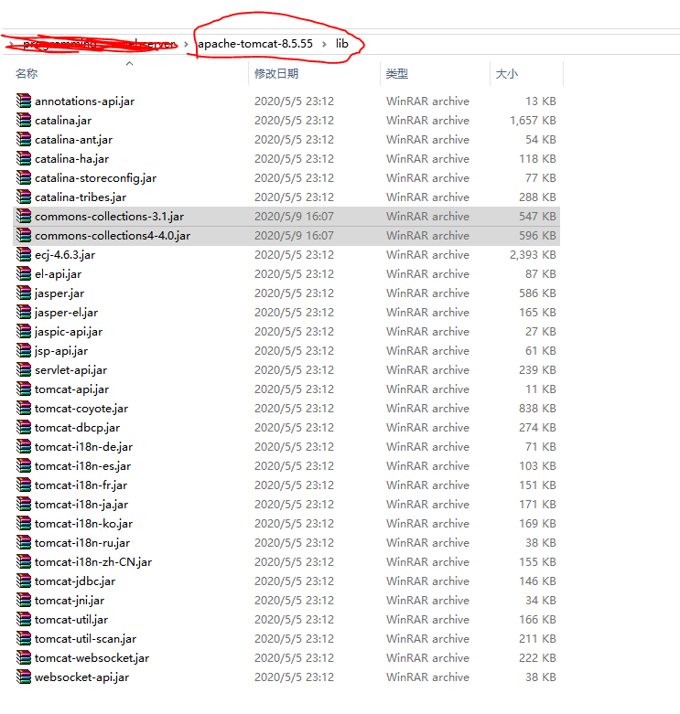
- 使用代码仓的工具发送反序列化代码
Use my tool send the exp

- 成功弹出notepad
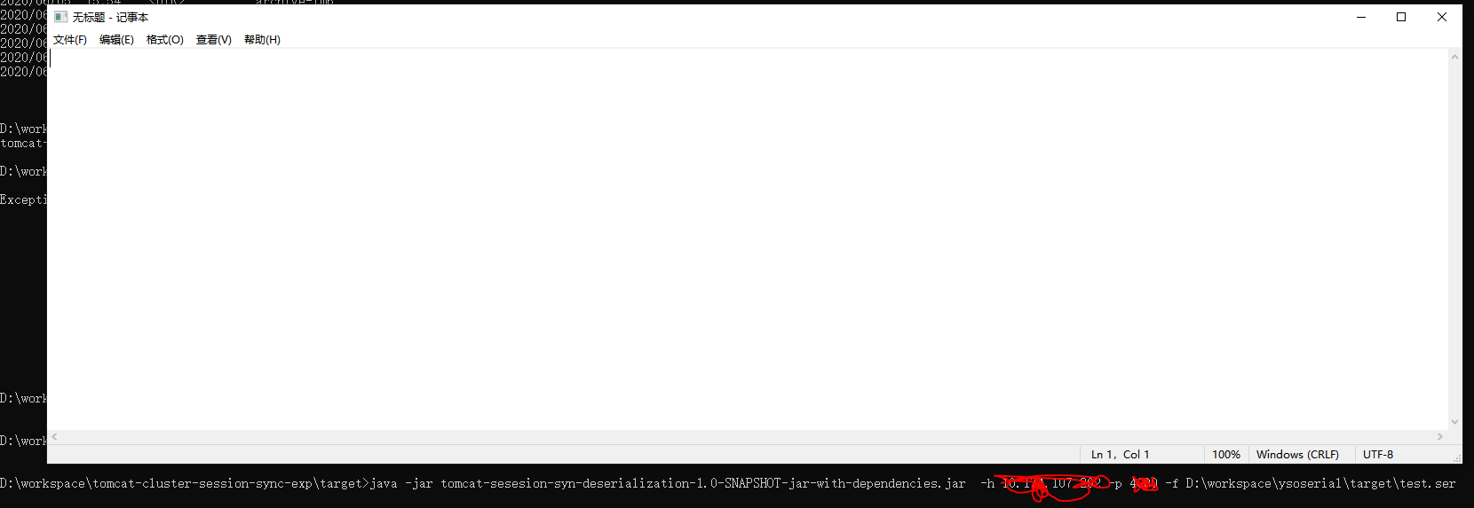
Successfully exploit

